Practical No:03

**Aim:** Installing and Removing Software: Install a gcc Package. Verify that it runs and then remove it.

**Installation of gcc package**

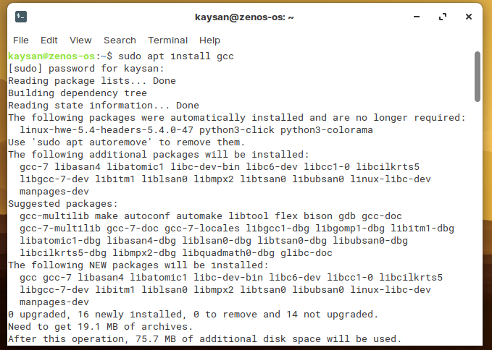

**To check whether its working or not , we check the gcc version by using simple command gcc --version.**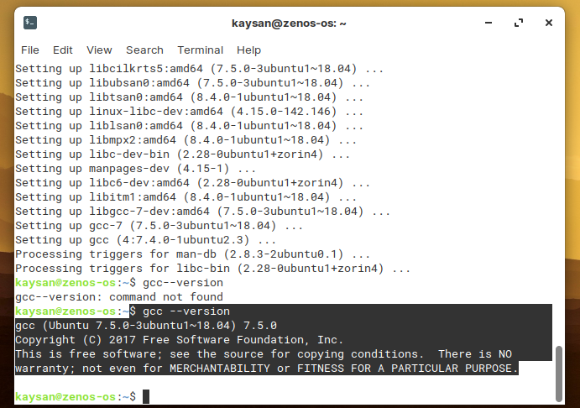

**Uninstalling the package**

